Smart Electric Catalogue
Customised energy saving lighting solutions

Content
Product Philosophy at Smart Electric
Summary of product application
Smart electric offerings
Contact details.
Photo Glossary.

Product Philosophy at Smart Electric

At Smart Electric we offer an array of lighting solutions for applicability in various contexts. We offer the communities outstanding lighting solutions such as Decorative lighting, High Mast lighting and Street lighting. Each of which offers a strong developmental role to the societal infrastructure. All our products have 3- 5 year warranty and we offer a very high degree of customization based on our clients needs.

Our value proposition stems from delivering high quality lighting solutions with impeccable service. This catalogue is a comprehensive representation of our offered products. Each section includes an in-depth representation of the product uses and data sheets. For more information please do not hesitate to contact us through our various contact points. All our projects offer energy saving solutions to the communities, for a more suitable future. The figure and table below outline the array of products offered by Smart electric. In Addition, it explains the warranty policy, lifetime ranges and product applications.

**Products (digram) visually displaying all names ( to be done as shown below)

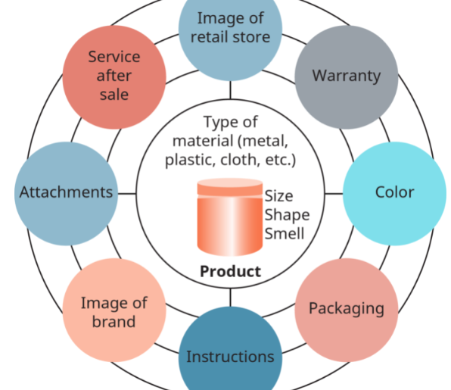

Product NAme | Offerings | Applications | Warranty | Lifetime | After Sale.
Street lighting | Curve , Flat.. | nnn | nnn
Decorative Lighting
High Mast

Decorative lighting (Venus and Apollo)

The Apollo Garden Lights

The LED Street Light Venus

The LED Street Light Venus offered by Smart Electric is known for its sustainability and environment friendliness. This is due to it’s Photocell and dimmable function. This product is considered perfect for outdoor application as a result of it’s durable chip and fade resistant powder coat finish.

Three to FIVE Years Warranty
50,000hrs working life
** Should be just displayed graphically or through design

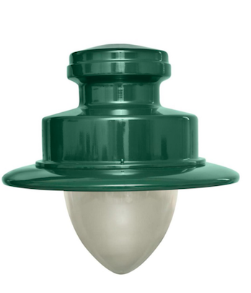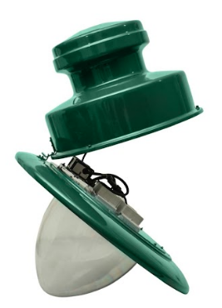
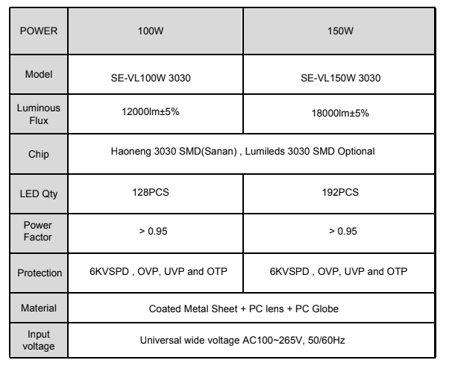

Street Lighting

The Smart “1”

Our very own first product into the market. Smart Offers high quality 3030 SMD chip, super bright up to 110-130lm/w. Further to that, other product benefits include;
Ø Constant current & Isolated Driver
Ø Power Factory: ≥0.95 @230VAC
Ø High heat-conductive Aluminum massive fins cooling technology
Ø Beam angle : 70°*140°
Ø IP65 Waterproof

60,000hrs working life
Ø 3-5 years warranty

OPTIONAL ------ Support photocell : The lights will be turned on automatically at night,
automatically turned off in the morning.
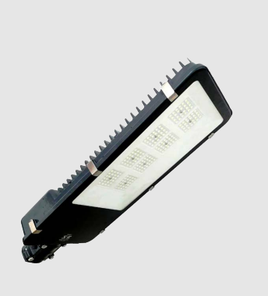
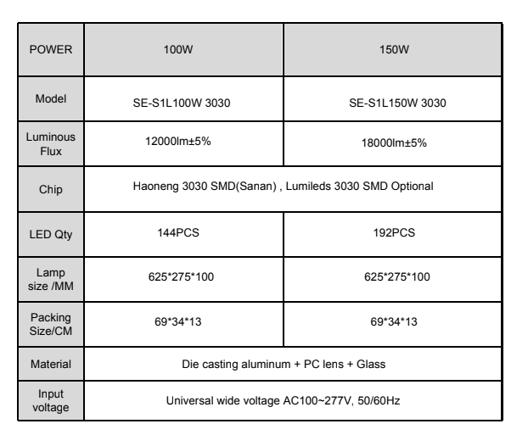

Th LED Street Light Flat

This Product offers high quality 3030 SMD chips, super bright up to 120-130lm/w. Other product benefits include:
Ø Constant current & Isolated Driver
Ø Power Factory: ≥0.95 @230VAC
Ø High heat-conductive Aluminum massive fins cooling
technology
Ø Beam angle : 70°*140° with 30° polarized.
Ø IP65 Waterproof

>70,000hs Life time
3-5 years warranty

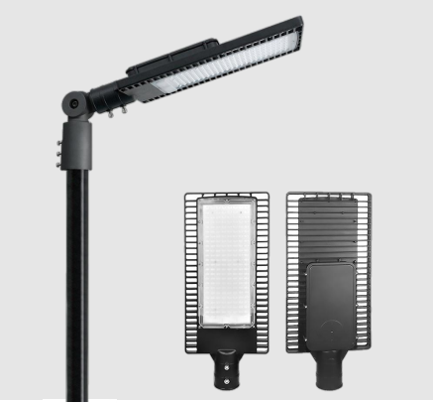

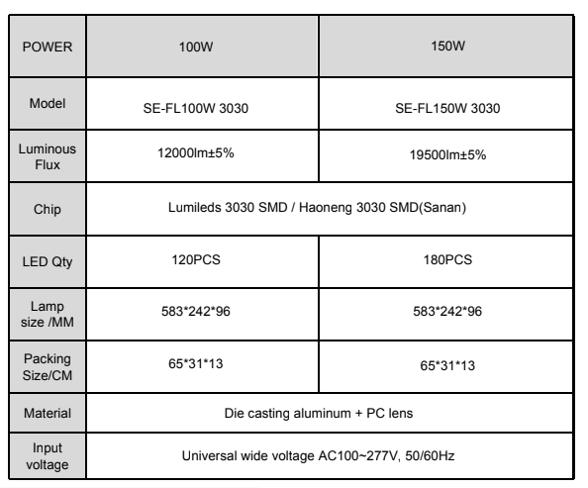

The LED Street Light Curve

This product offers a high quality 3030 SMD chip, super bright up to 130-140lm/w. Additional to that, The Street Light Curve offers protection against low voltage, overLoad, short circuit , over temperature, Over Voltage. Its advantageous features also includes:
- Constant current & Isolated Driver
- Power Factory: ≥0.95 @230VAC
- High heat-conductive Aluminum massive fins cooling technology
- Beam angle : 70°*140°
- IP66 Waterproof protection
- IK08 impact protection

3 - 5 years warranty
>60,000hs Life time.

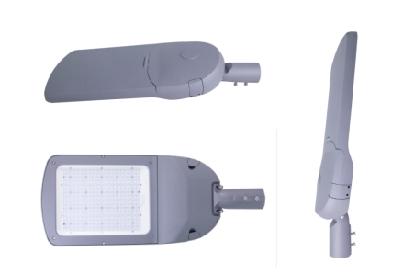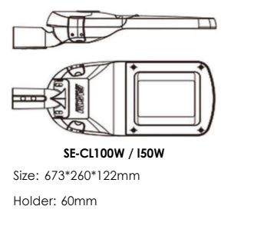

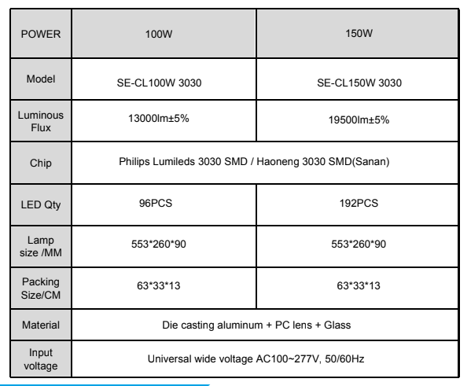

The High Mast

The Led Stadium Lights

This series is excellent for high quality sports flood lighting. The LED Stadium Light can instant start, and has long life span, low consumption of energy, and polluting-free.It can be widely used at the stadium, golf course, wharf, square,etc.This products provides high quality and meets the requirement of professional light distribution, Also, it can restrain the dazzle light and spill light effectively. This series has been processed by electrostatic paint, and passed a 200 hours salt spray test. Other product benefits includes;

- The module heatsink has excellent thermal performance.
- Professional design, full protection, by using water-proof connector and silicon rubber sealing, the protection rate can achieve IP65,and eliminating mist, improving quality, and extending the life span.
- Reliable quality, remarkable performance. The entire housing coated by electrostatic
- paint;240oadjustable angle.

3- 5 years warranty
​​50,000 life time

